**Chematix**

This is the name of the online platform that we use to manage our chemical inventory. If you need access and do not have it, please tell the lab manager and her or she will be able to give you access to it. The following is a set of instructions of how to do the basic functions in Chematix.

**Adding Chemicals**

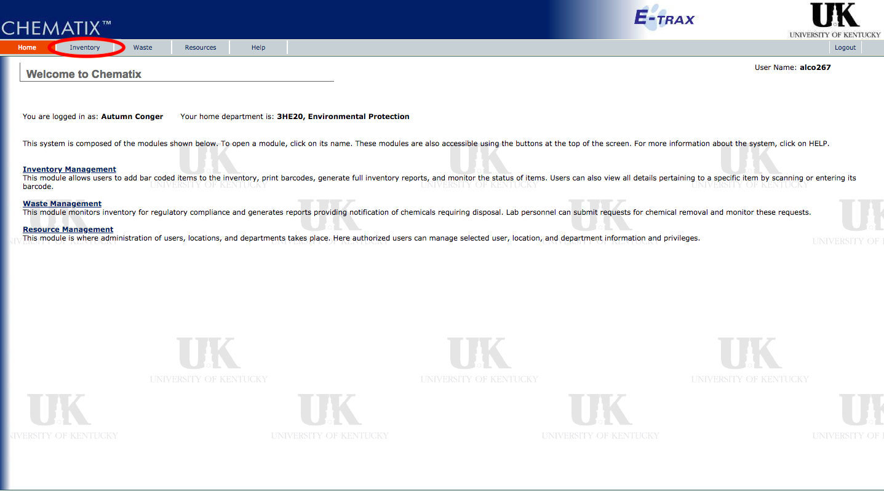

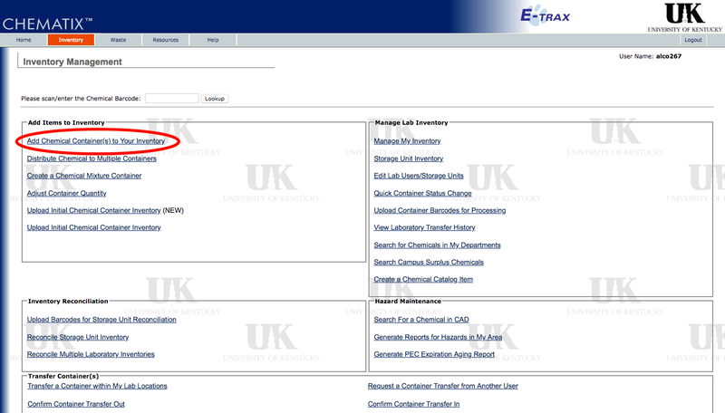

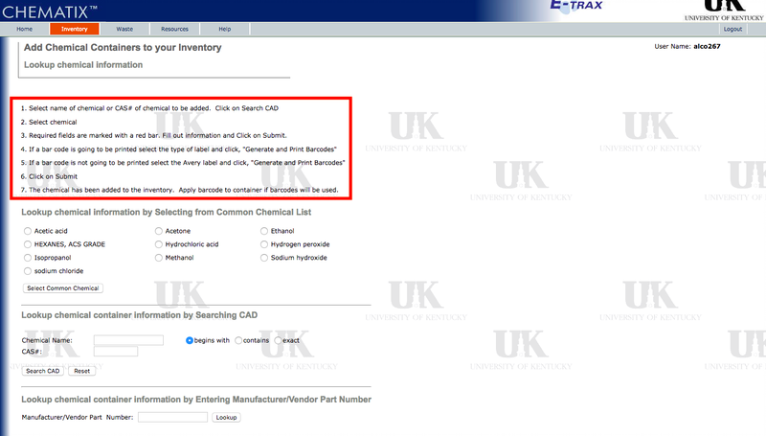

**Manage the Inventory**

Intentionally left blank

**Edit Lab Users**

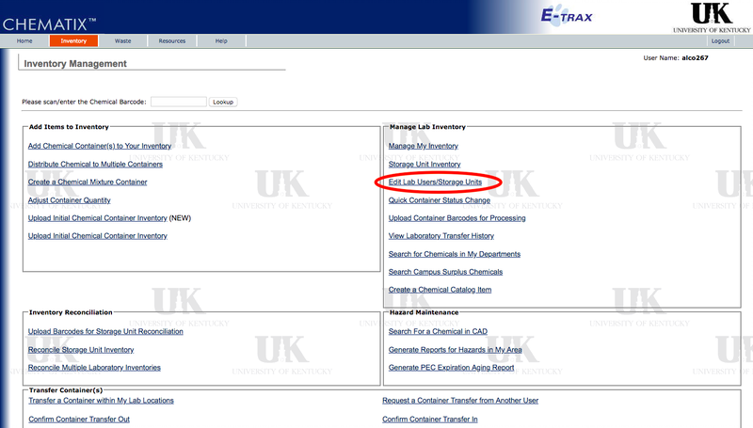

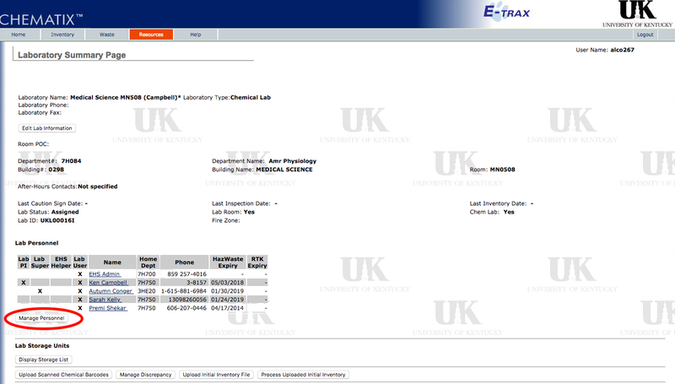

**Create a Chemical Mixture Container**

Intentionally left blank

**Waste** **Management**

After you have logged into Chematix, click on the waste tab (shown in the picture below).

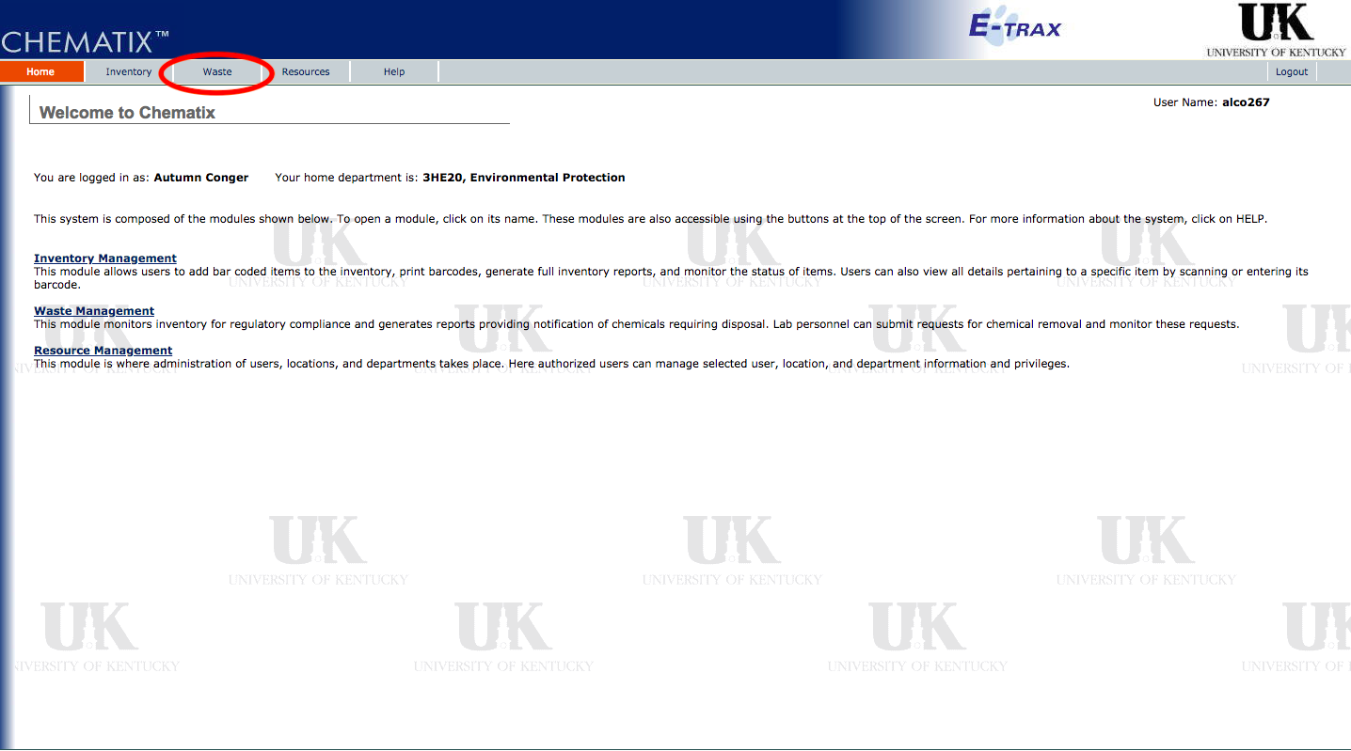

When you have reached the Waste tab, click on the Waste Management link. Once you are inside this link, you may chose which action you need to take. If you are attempting to get rid of chemicals for the lab, chose the 'Create Waste Card' option (shown below).

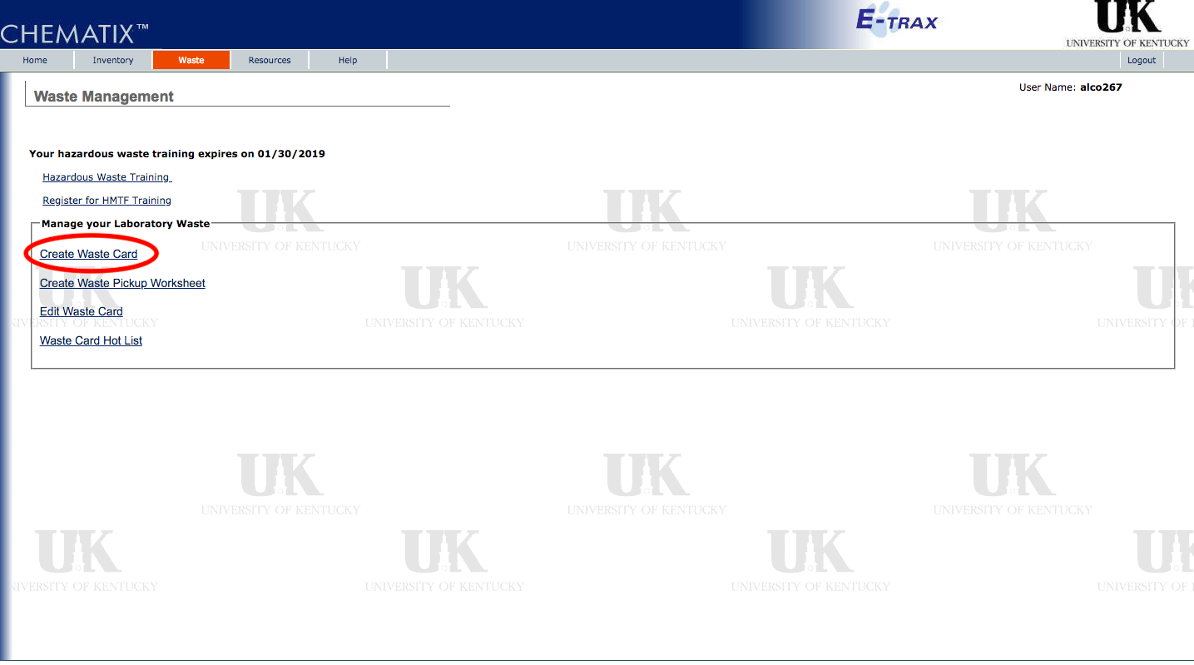

Once you have chosen the Create Waste Card link, you will have to chose which type of chemical you are making the card for. The majority of the time, the Pure Chemicals in Individual Containers will be chosen. Occasionally, the chemical mixture by percentage will also be used. After clicking on the Pure Chemicals link, you may now begin filling out the waste card. The accumulation start date, is the date that you began accumulating hazardous waste to be disposed of. Additionally, make sure that your information in the box is correct (i.e. name, number, and department)

**NOTE**: If you are making a waste card for sharps, look under the pure chemical in original container option and type 'sharps'.

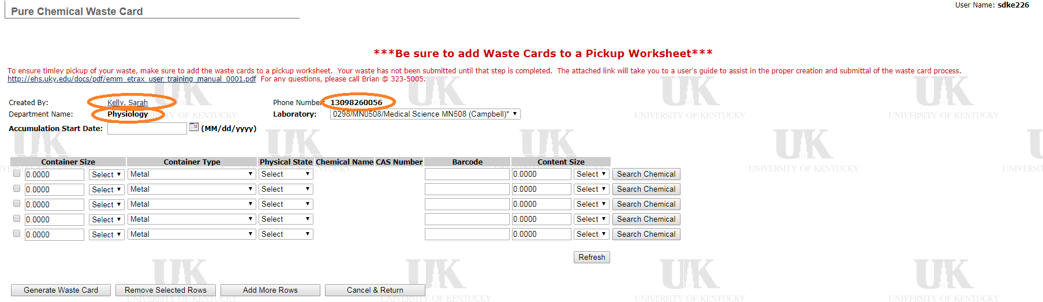

Now you may began adding that chemicals that need to be disposed of. The easiest way to do this is to click on the search chemical tab, and entering the CAS# for the chemical. (If there is not a CAS # you may enter the name). After the CAS# has been entered, the system will bring up a list of options that you may chose from. Select the name that most closely resembles the name present on the bottle. Next, chose the container size, container type (most likely polyethylene or glass) and the physical state. Also, give your best estimate for how much of the chemical is left in the container. This will go under content size. However, if there is nothing left in the container, the system will not allow you to enter zero. Instead, simply enter a small quantity that makes sense with the overall container size. Example: 250 mL container size, insert 1mL. Continue to do this for all chemicals that you have. You can also add more rows to the worksheet by clicking on the 'Add More Rows' option.

Once you have completed adding all of your pure chemicals to the list, select the 'Generate Waste Card' option. After selecting this, proofread all of your cards to make sure the information is correct, and then select Print Waste Cards.

**NOTE**: Even if you have multiples of the same chemical, EACH chemical must get its own waste card. All of the waste cards have bar codes located on them. Therefore, you cannot make one Image Development Reagent waste card and print it twice. You MUST make two separate card with different bar codes for each reagent bottle.

For chemical mixtures that are not in the original bottle, but are in a glass container, use the Chemical Mixture by Percentage waste card option. Make sure to fill out the container size/unit, container type, physical state, and the percentage of the container filled. This are all located above where you inserted the chemical types and may be easy to miss. Then, add the chemicals that are present in the mixture by searching for their name and entering the estimated percentage of each chemical. If there is only one chemical present in the solution, but it is technically a chemical mixture, make the percentage as 100%. It is important to note that the system will not allow you to generate the waste card unless all of the percentages are equal to 100.

Now that you have generated the waste cards, print each of them out. When printing, make sure that the 'print on both sides' option is not selected. Then, cut out the cards and tape them to the container.

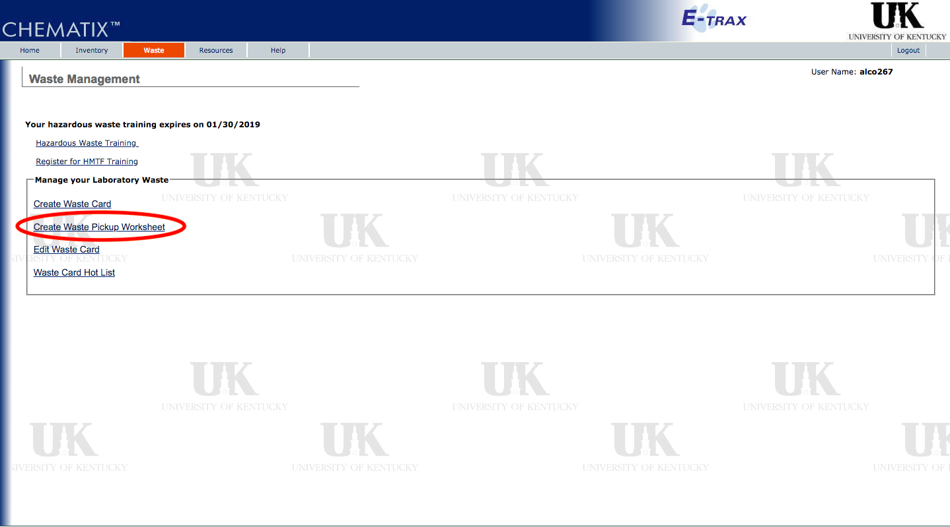

Once here, make sure that your information is correctly listed, select the location, and indicate if your waste exceeds 55 gallons or 1 quart of p-listed chemicals. Finally, under the instructions tab dictated where the chemicals are located (i.e. on your right side once entering the lab, on lab bench). Finally, indicated in this same tab when someone will be present to make sure that the door is unlocked for the waste pickup.

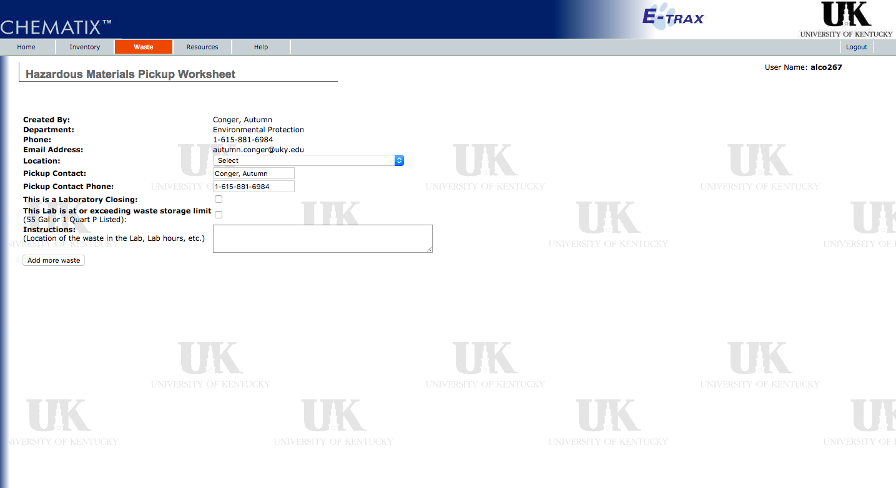

Once you have submitted this worksheet, you may check on the status of your waste pickup worksheet, under the waste tab, and review what all you have submitted! Someone should then be by within the next few business days to collect your waste.

More instructions are located in How to Create Waste Card.pdf